**Curriculum Guide and Worksheets**

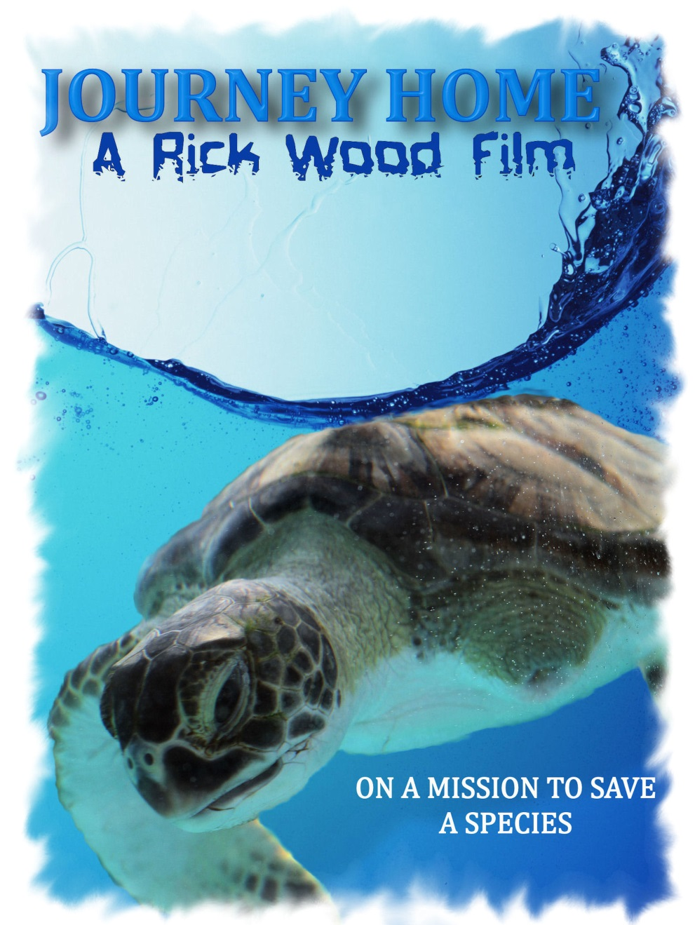

**Vocabulary:**

**C:\Users\Rick\AppData\Local\Microsoft\Windows\Temporary Internet Files\Content.IE5\YNYSDY5O\MC900016547[1].wmfEndangered**

**Conservation**

**Rehabilitation**

**Carapace**

**Plastron**

**Kemps Ridley**

**Leatherback**

**Hawksbill**

**Loggerhead**

**Habitat**

**Pollution**

**Hatchling**

**Choose a word from the list above and write the definition:**

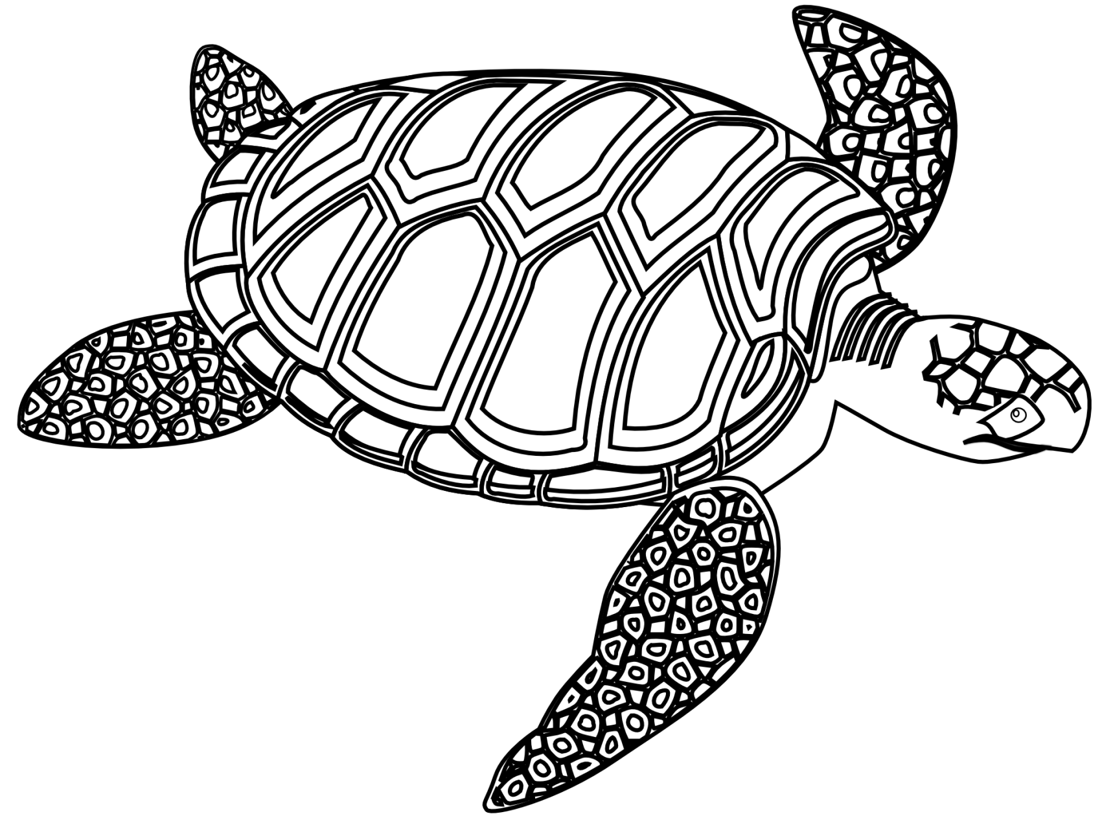**What colors are sea turtles?**

**Name some of the body parts:**

**1.**

**2.**

**3.**

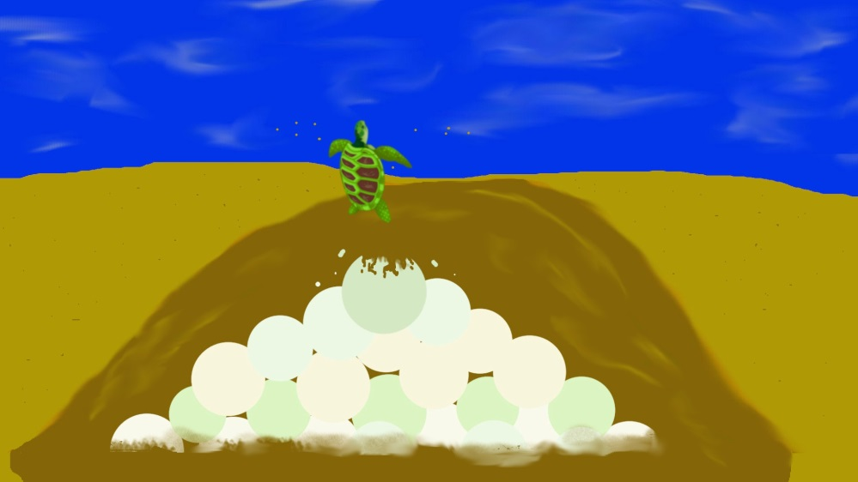

**Life Cycle**

True or false:

1. Sea turtles lay eggs. True False
2. Female sea turtles stay with their young. True False
3. Sea turtles mostly live on land. True False
4. Sea turtles breathe air. True False
5. Some sea turtles live more than 80 years. True False

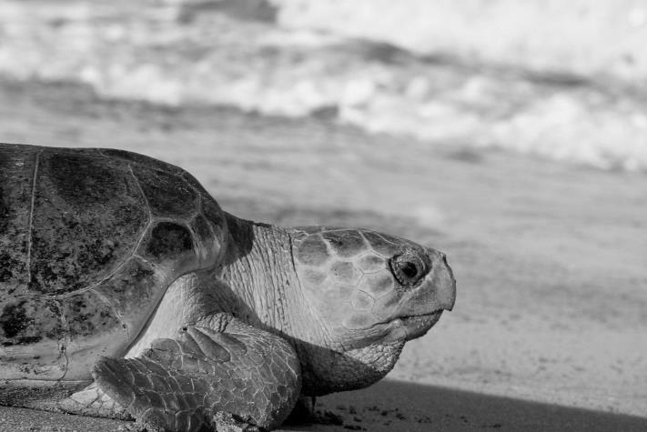

Sea Turtle

**DANGERS!!!**

Which of these are dangerous for sea turtles? Circle the best answers.

C:\Users\Rick\AppData\Local\Microsoft\Windows\Temporary Internet Files\Content.IE5\YNYSDY5O\MC900338476[1].wmfC:\Users\Rick\AppData\Local\Microsoft\Windows\Temporary Internet Files\Content.IE5\YRG6MD47\MC900030485[1].wmf 

 

  

Answers: Fishing line, balloons, fast food cup, shark, boat, seagull

Critical Thinking Questions

What can be done to help sea turtles?

How does the environment play a role in the health of sea turtles?

What did you learn from watching the film?

Additional Resources:

Loggerhead Marinelife Center www.marinelife.org

Sea Turtle Conservancy www.conserveturtles.org

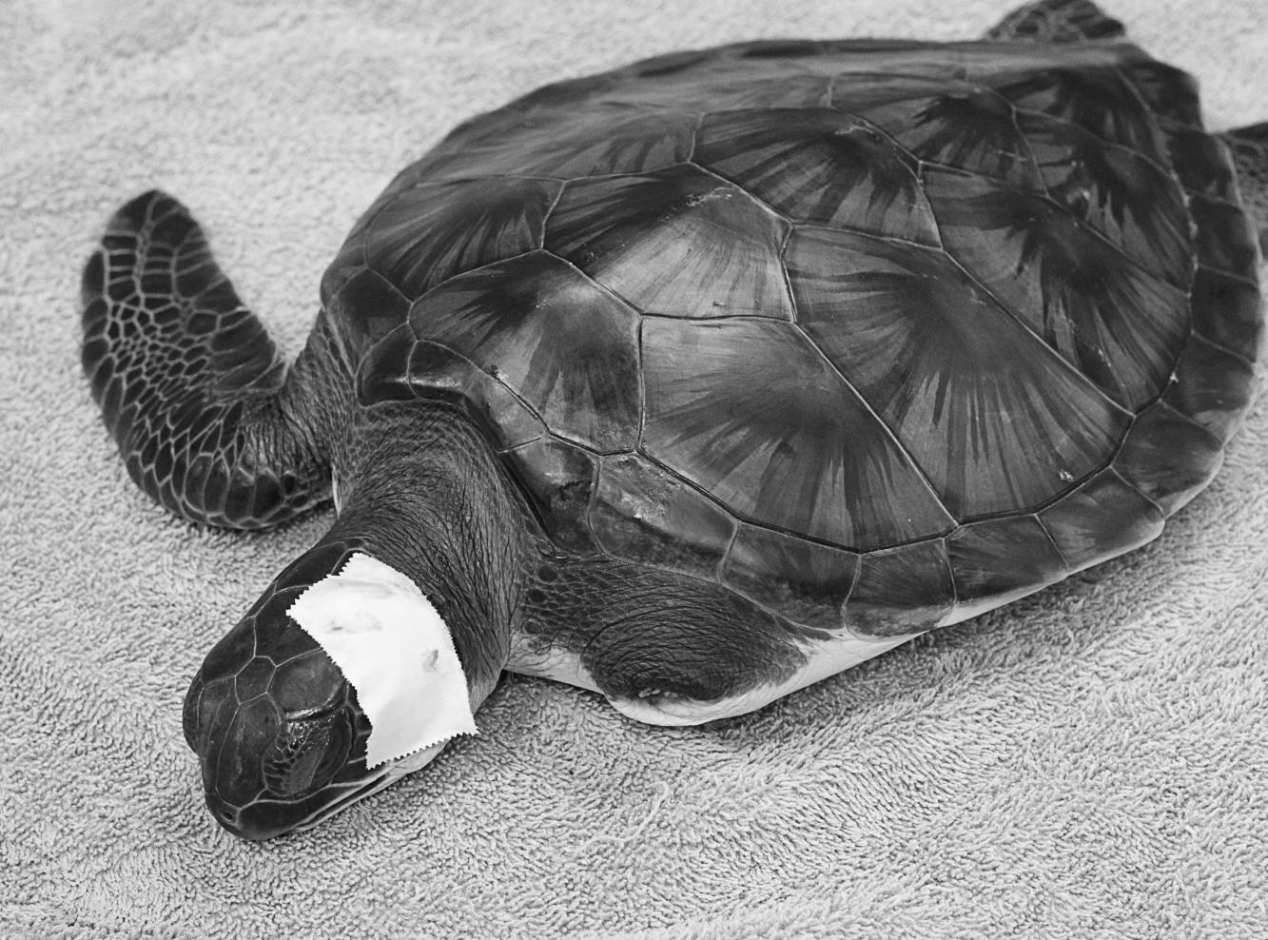

*If you have further comments or questions, please visit: seaturtlejourneyhome.weebly.com*